**Limitation of Procedural Programming (Business Application):**

**Disjoint data:**

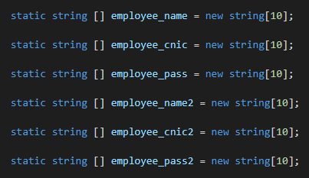

As data is highly correlated but it is stored in disjoint arrays and linked with index numbers. There are multiple arrays in this app which are associated with index number.

**Data Management issues:**

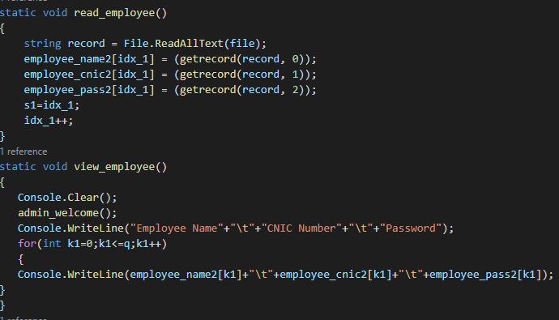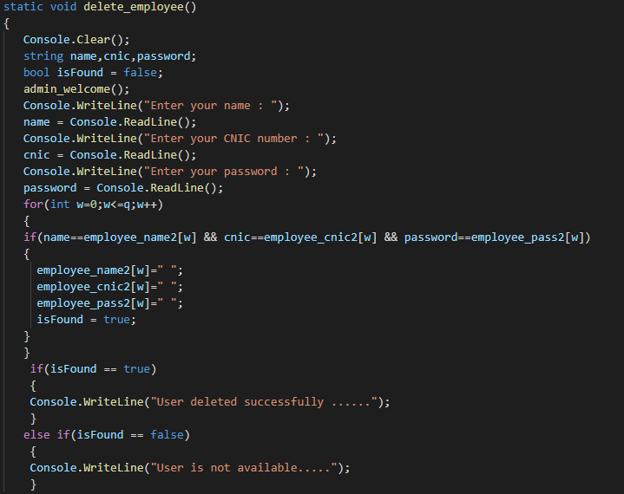

As data is fetched by the index in arrays and viewed by index and change in index can create any problem and we can’t get the desire index and output.

**Constraint on Data:**

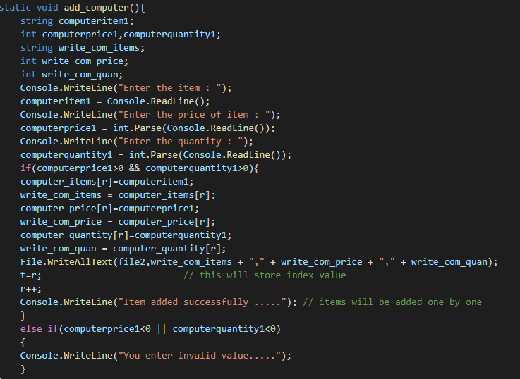

I have used if else conditions but procedural programming didn’t assure the limit for value. As for this project procedural programming will not restrict quantity to be less than 0.

**Function Different Behavior:**

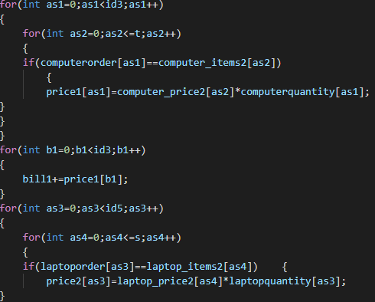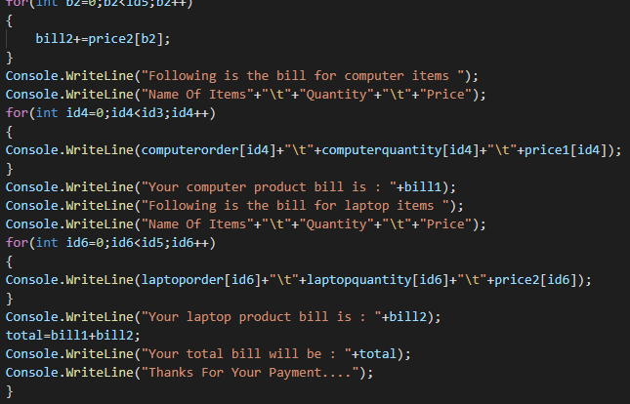

As for payment of bill, there are many limitations i:e data management limitation(index fetching issue , disjoint data) function limited behavior. In this function, I have declare formula for both laptop and computer collected bought items bill so the procedural programming is limited and not allow one function to behave differently for computer and laptop.

**Partial Access to functions:**

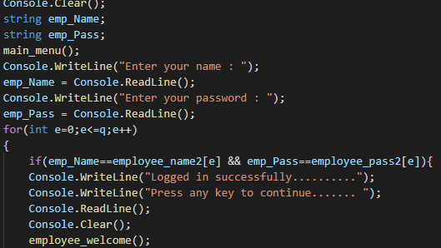

As employee is register by admin in its own function but for another function for employee, registered employee is required to be checked in second function but due to procedural programming limitation, registered employee is not check if the arrays are local. For this, we need to declare global arrays and we not have partial access to that function to have access to its declared arrays.